1. Draw a state diagram for nondeterministic finite automata that accepts the following languages

There can be multiple answers, below is one example answer.

**

1. Give the regular expression for the language accepted by the following finite automaton:

There can be multiple answers, below is one example answer.

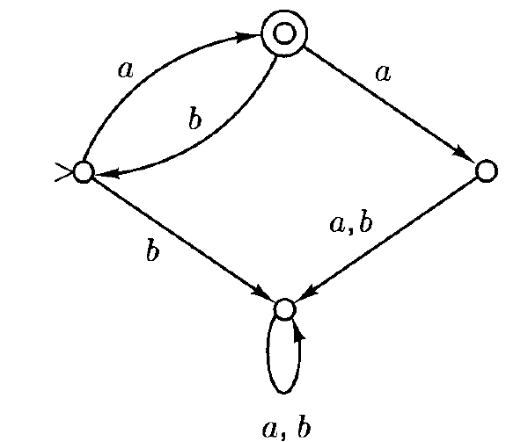

1. Write the regular expression for the following sets
   1. All strings over $\{a,b\}$ that are odd in length
 $${\left(a∪b\right)\left(\left(a∪b\right)\left(a∪b\right)\right)}^{*}$$

  2. All strings over $\left\{a,b\right\}$ that end with $bb$

$${\left(a∪b\right)}^{*}bb$$